DAY – 8

1. **To convert the UML Circle-Class Diagram to Typescript class.?**

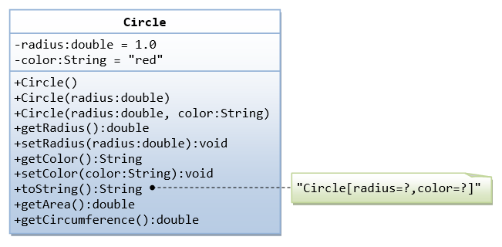

/**

* The Circle class models a circle with a radius and color.

*/

public class Circle { // Save as "Circle.java"

// private instance variable, not accessible from outside this class

private double radius;

private String color;

// Constructors (overloaded)

/** Constructs a Circle instance with default value for radius and color */

public Circle() { // 1st (default) constructor

radius = 1.0;

color = "red";

}

/** Constructs a Circle instance with the given radius and default color */

public Circle(double r) { // 2nd constructor

radius = r;

color = "red";

}

// 3rd constructor to construct a new instance of Circle with the given radius and color

public Circle (double r, String c) { ...... }

/** 4. Returns the radius */

public double getRadius() {

return radius;

}

// 5. Setter for instance variable radius

public void setRadius(double newRadius) {

radius = newRadius;

}

// 6.Getter for instance variable color

public String getColor() { ...... }

// 7.Setter for instance variable color

public void setColor(String newColor) { ...... }

/** 8.Return a self-descriptive string of this instance in the form of Circle[radius=?,color=?] */

public String toString() {

return "Circle[radius=" + radius + " color=" + color + "]";

}

/** 9. Returns the area of this Circle instance */

public double getArea() {

return radius*radius*Math.PI;

}

// 10. Test getArea() and getCircumference()

System.out.printf("area is: %.2f%n", c1.getArea());

System.out.printf("circumference is: %.2f%n", c1.getCircumference());

}

}

1. Write a “person” class to hold all the details?

class Person {

constructor(firstName, lastName) {

this._firstName = firstName;

this._lastName = lastName;

}

get fullName() {

return `${this.firstName} ${this.lastName}`

}

get firstName() {

return this._firstName

}

get lastName() {

return this._lastName

}

sayHi() {

return `Hi, ${this.firstName} ${this.lastName}`

}

set firstName(firstName) {

this._firstName = firstName;

}

set lastName(lastName) {

this._lastName = lastName;

}

}

const person = new Person('Jane', 'Smith');

person.firstName = 'John';

person.lastName = 'Doe';

console.log(person.firstName, person.lastName)

1. write a class to calculate uber price.?

{

"prices": [

{

"localized_display_name": "POOL",

"distance": 6.17,

"display_name": "POOL",

"product_id": "26546650-e557-4a7b-86e7-6a3942445247",

"high_estimate": 15,

"low_estimate": 13,

"duration": 1080,

"estimate": "$13-14",

"currency_code": "USD"

},

{

"localized_display_name": "uberX",

"distance": 6.17,

"display_name": "uberX",

"product_id": "a1111c8c-c720-46c3-8534-2fcdd730040d",

"high_estimate": 17,

"low_estimate": 13,

"duration": 1080,

"estimate": "$13-17",

"currency_code": "USD"

},

{

"localized_display_name": "uberXL",

"distance": 6.17,

"display_name": "uberXL",

"product_id": "821415d8-3bd5-4e27-9604-194e4359a449",

"high_estimate": 26,

"low_estimate": 20,

"duration": 1080,

"estimate": "$20-26",

"currency_code": "USD"

},

{

"localized_display_name": "SELECT",

"distance": 6.17,

"display_name": "SELECT",

"product_id": "57c0ff4e-1493-4ef9-a4df-6b961525cf92",

"high_estimate": 38,

"low_estimate": 30,

"duration": 1080,

"estimate": "$30-38",

"currency_code": "USD"

},

{

"localized_display_name": "BLACK",

"distance": 6.17,

"display_name": "BLACK",

"product_id": "d4abaae7-f4d6-4152-91cc-77523e8165a4",

"high_estimate": 43,

"low_estimate": 43,

"duration": 1080,

"estimate": "$43.10",

"currency_code": "USD"

},

{

"localized_display_name": "SUV",

"distance": 6.17,

"display_name": "SUV",

"product_id": "8920cb5e-51a4-4fa4-acdf-dd86c5e18ae0",

"high_estimate": 63,

"low_estimate": 50,

"duration": 1080,

"estimate": "$50-63",

"currency_code": "USD"

},

]

}